www.mvcac.org

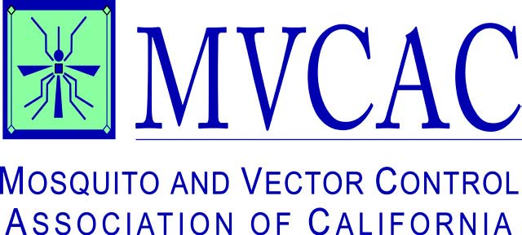
1215 K Street, Suite 940
Sacramento, CA 95814
p 916.440.0826
f 916.231.2141

November 13, 2012

VIA EMAIL and US MAIL

Tessa Fojut
Central Valley Regional Water Quality Control Board Office
11020 Sun Center Drive, Ste. 200
Rancho Cordova, CA 95670
tfojut@waterboards.ca.gov

Re: CEQA Public Scoping Period for Central Valley Pyrethroid Pesticides TMDL and Basin Plan Amendment

Dear Ms. Fojut:

On behalf of the Mosquito and Vector Control Association of California (MVCAC), we thank you for the opportunity to provide comments regarding the potential environmental impacts resulting from the proposed pyrethroid TMDL and Basin Plan Amendment.

MVCAC represents over 60 local government agencies that provide mosquito and vector control services to protect the health of California’s citizens. MVCAC’s mission is to provide quality public information, comprehensive mosquito and vector-borne disease surveillance, and training to high professional standards, on behalf of California mosquito and vector control districts.

According to the Center for Disease Control, deaths from West Nile Virus reached an all-time high of 228 this year. Sixteen deaths and 395 total cases have been reported in California. Mosquito resistance to pesticides is increasing. Therefore effective integrated mosquito management programs require a rotation of pesticides with different modes of action. Pyrethroids are an essential pesticide for adult mosquito control. Any limitation to the use of pyrethroids in this rotation would compromise MVCAC’s members’ capability to control adult mosquito populations responsible for disease transmission.

Of the 126 Priority Pollutants listed for California, none are mosquito control pesticides such as pyrethroids. Priority Pollutants are selected after a multidisciplinary group of scientists conduct extensive and scientifically rigorous evaluation of their effects on the aquatic environment, and have been determined to be seriously toxic even at low levels. Pyrethroids used in mosquito control are not included in this list.
Any CEQA document examining the potential environmental impacts from limiting the use of pyrethroids pursuant to a TMDL should include a thorough examination of the following.

- The potential for conflicts with mosquito control plans of local districts.
- The potential to impact public services necessary to protect public health.
- The potential impacts to water quality from increased and unregulated homeowner use of store-bought pesticides resulting from limits the TMDL places on public health pesticide agencies.

Mosquito and vector control districts employ trained and licensed professionals who are knowledgeable on the appropriate uses of pesticides and are able to make judicious use of public health pesticides, by following their award-winning Integrated Pest Management program. According to a recently published paper by the California Department of Public Health, the uses of all types of mosquito control pesticides constitutes less than
1.0 % of total pesticide use in California. The percentage of pyrethroids is even smaller.

For these reasons, we urge the Central Valley Water Resources Control Board to consider an exemption for mosquito control pyrethroids from its proposed TMDL and Basin Plan Amendment.

Thank you for your consideration.

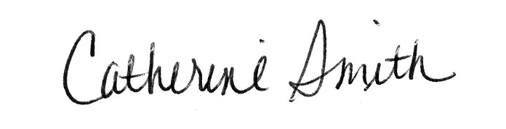
Most sincerely,

Catherine Smith
Executive Director

